**LOGIN APP DOCUMENTATION**

* **Drag and Drop the text view**
* **In attributes, change text to “*Login Form*”**

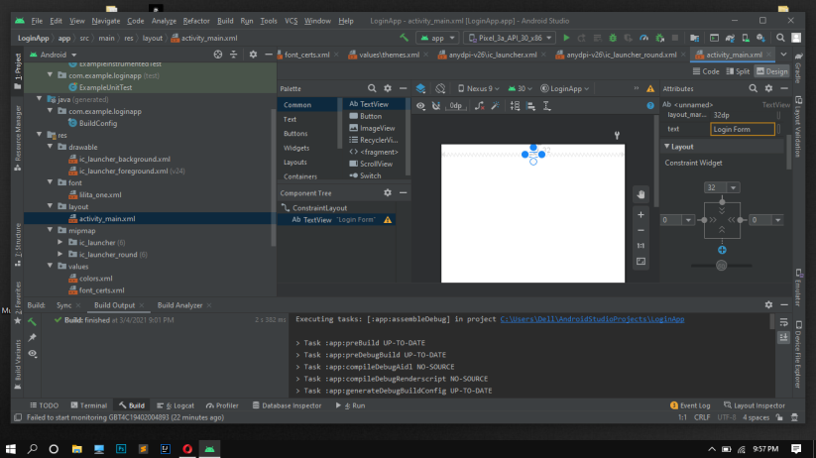

* **Increase the text size to “36sp”**

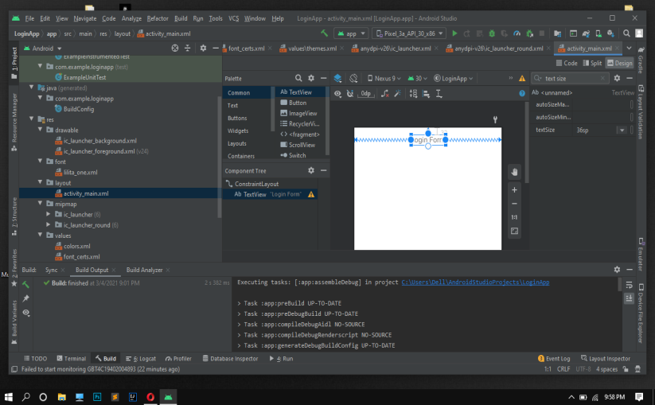

* **Change the font-family**

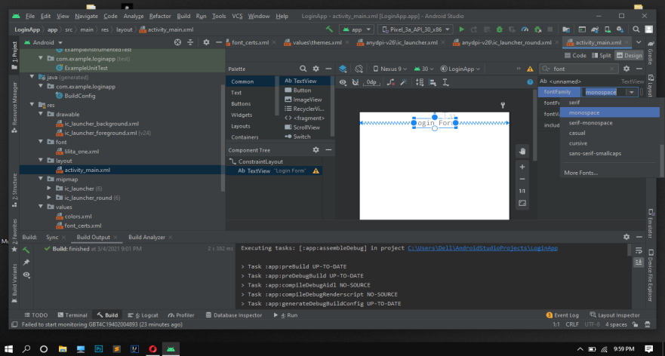

* **Apply “bold ”text style**

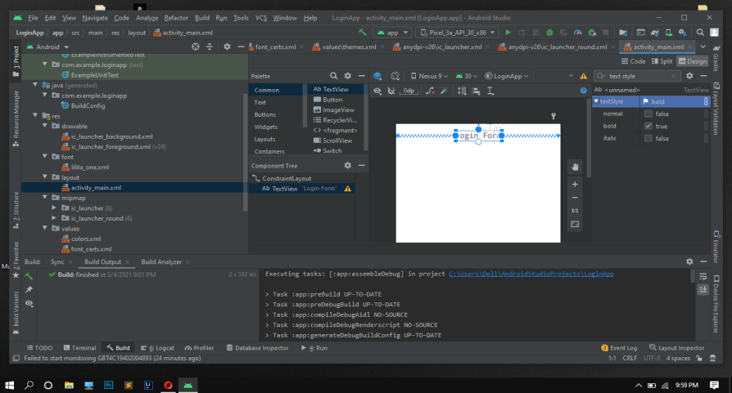

* **Change text color**

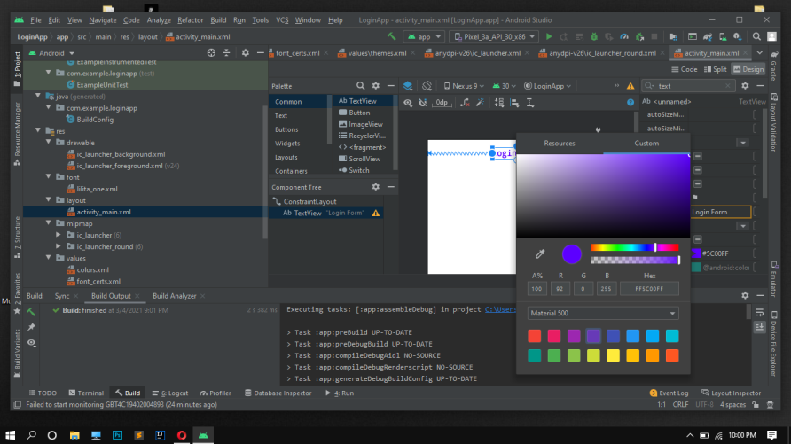

* **Drag and Drop text fields and buttons**

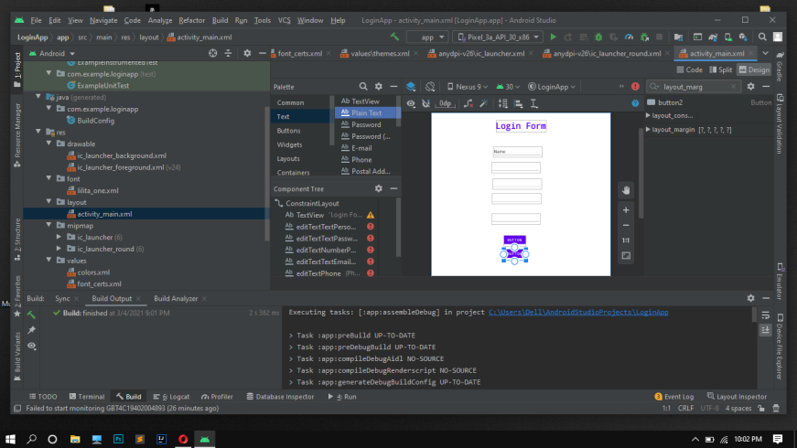

* **Remove the Name field and apply hint from attributes section**

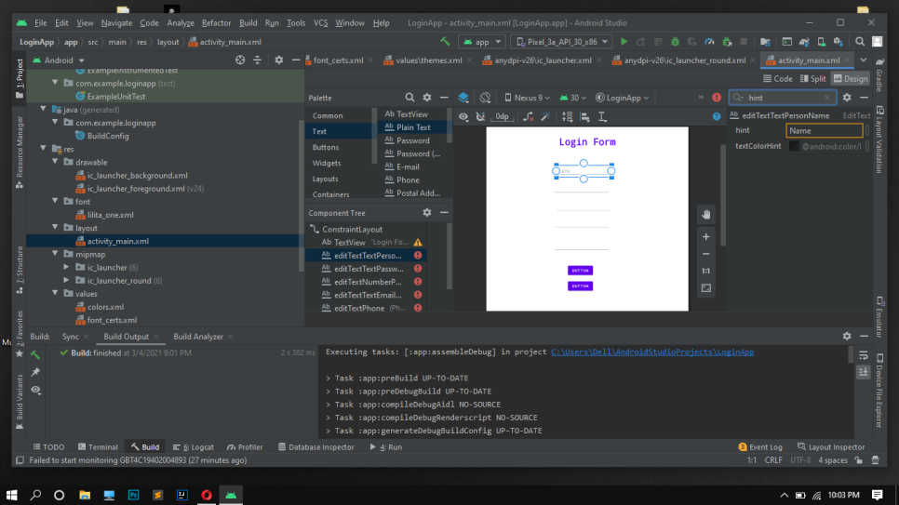

* **Apply vertical constraints to all field and align then center horizontally**

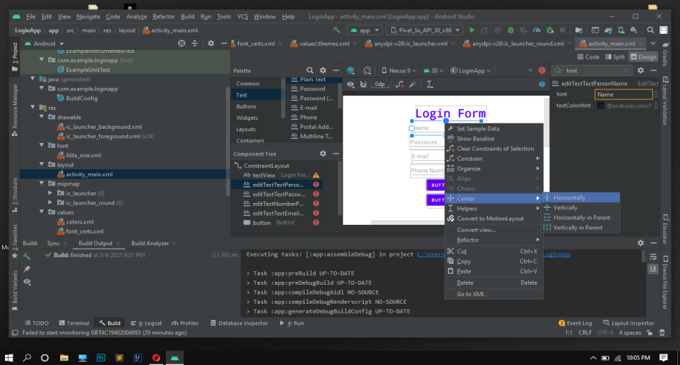

* **Changes the button text to “SIGN UP” & “LOGIN” respectively**

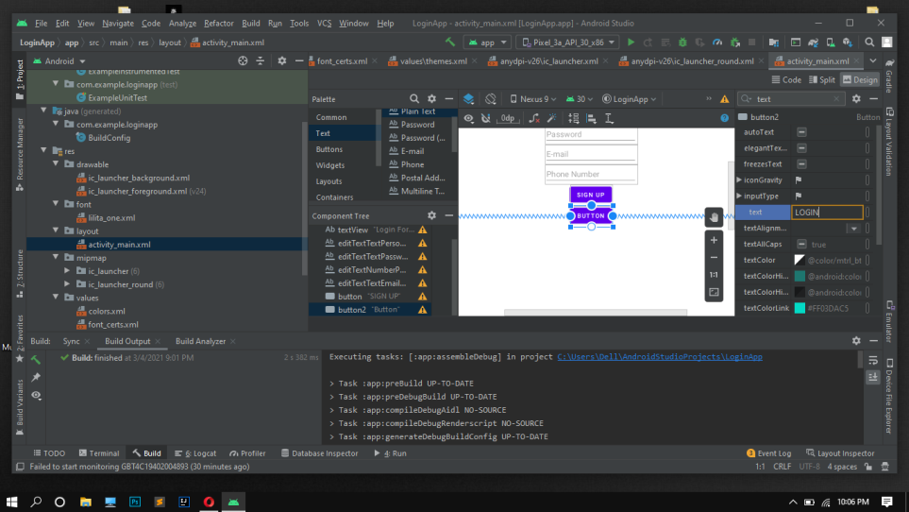

* **Apply padding to the heading “Login Form”**

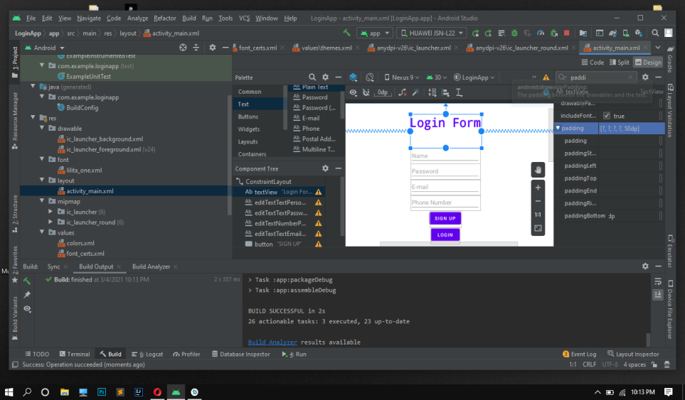

* **App Final Form running on device**

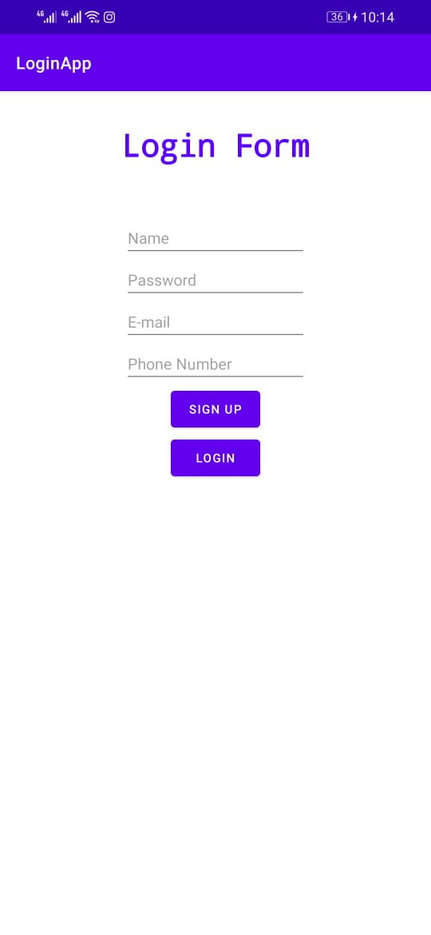

**“MESSAGE APP DOCUMENTATION”**

* **Drag and Drop all text and input fields**
* **Change text style and font-family**
* **Apply vertical and horizontal constraints**
* **Change text to hint**
* **Add required padding & margins**

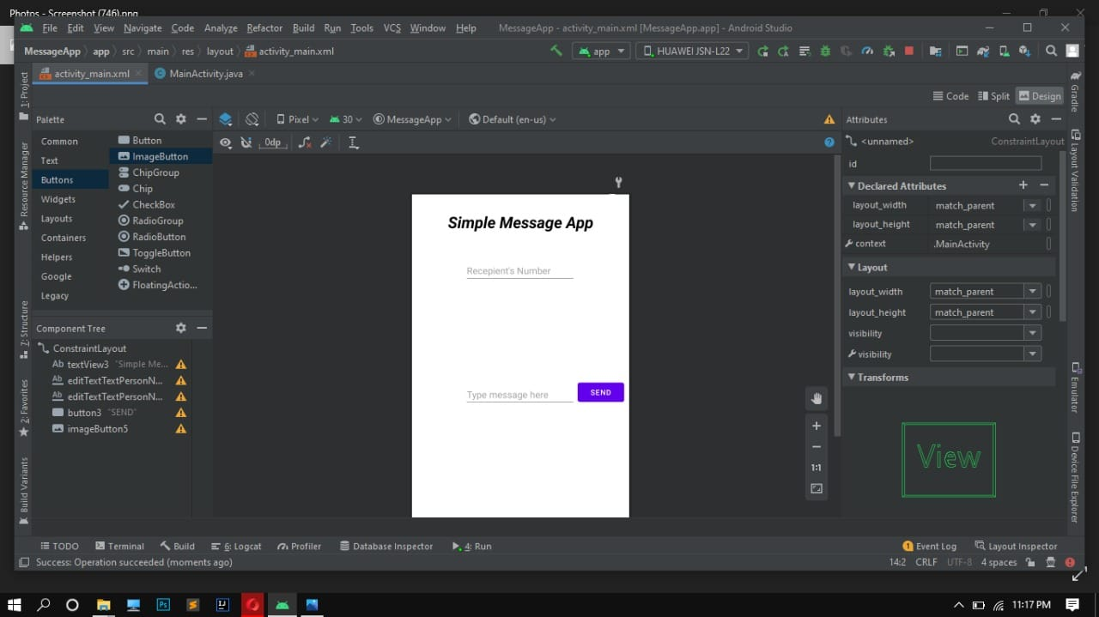

* **From image button, Select an image**

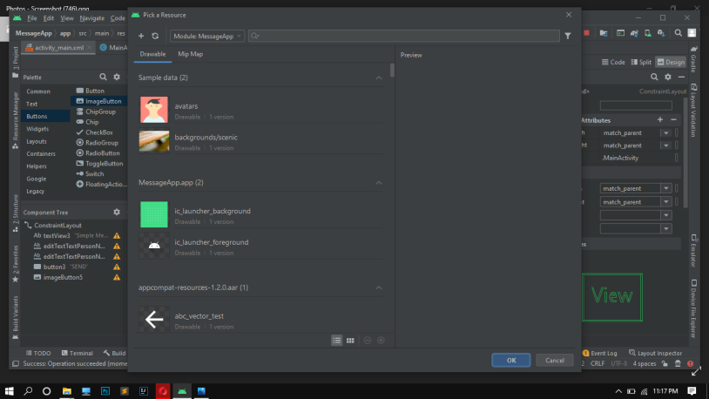

* **Add image on right side of input field**
* **Add horizontal and Vertical Constraints**

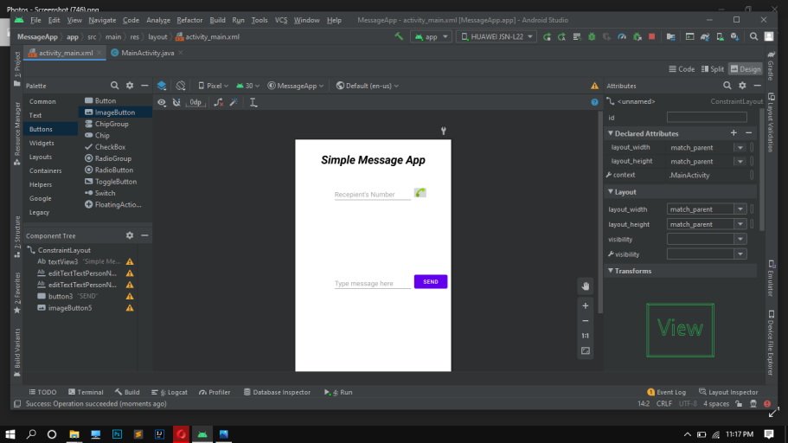

* **App final form running on device**

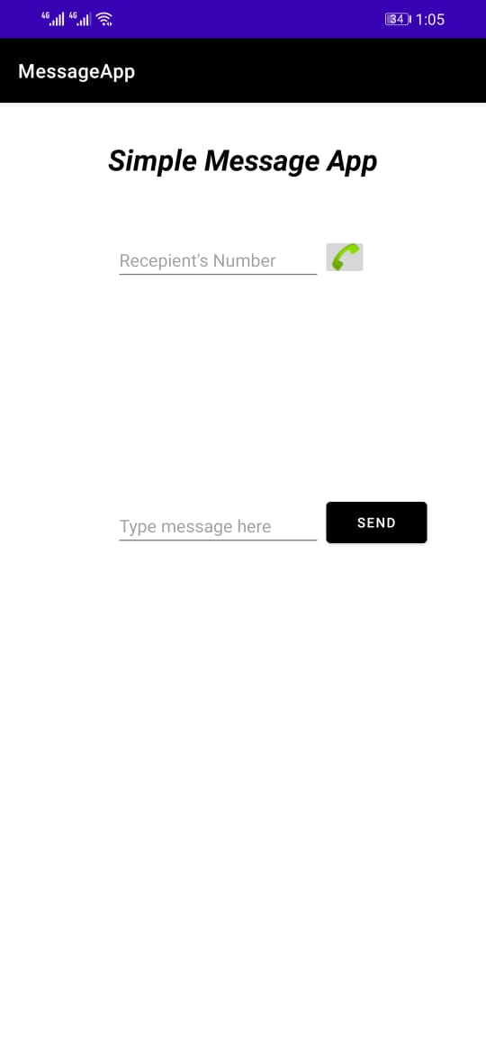

**“To-Do’s App Documentation”**

* **Copy and paste the background image in drawable directory**

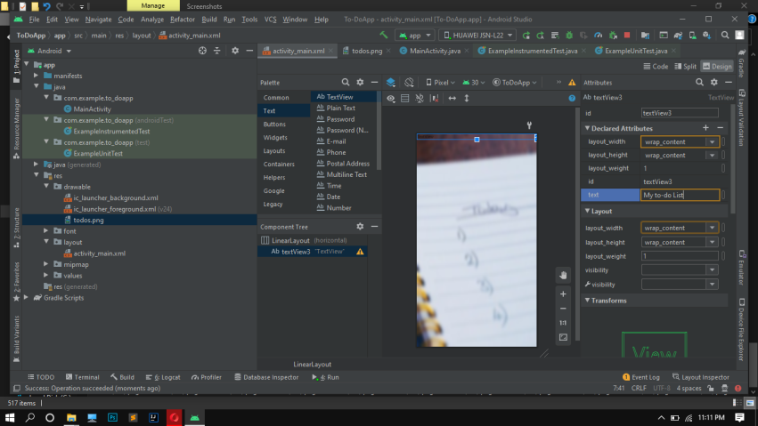

* **Add text view**
* **Increase text size**

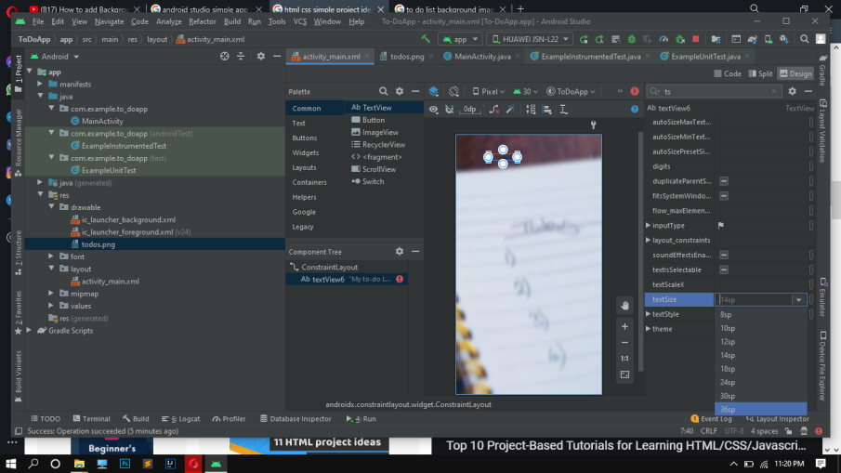

* **Change the text color to “WHITE”**

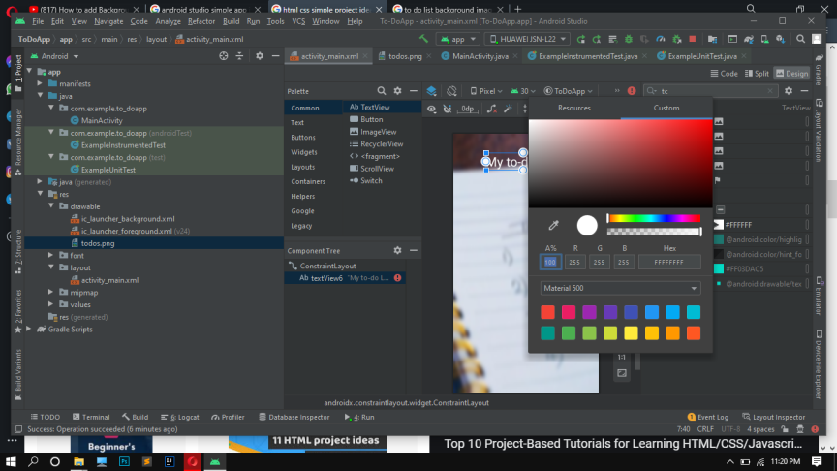

* **Change the font family**
* **Change font style to “bold”**

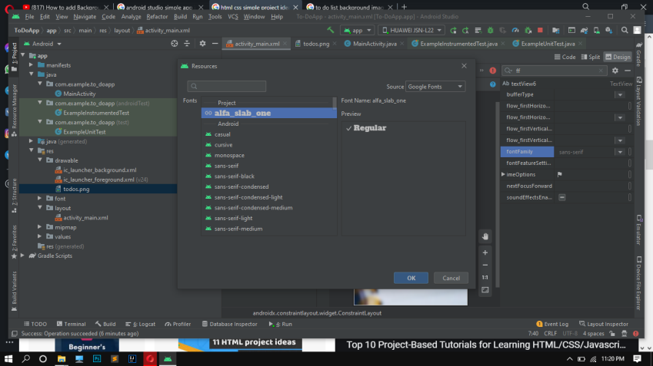

* **Apply some top padding**

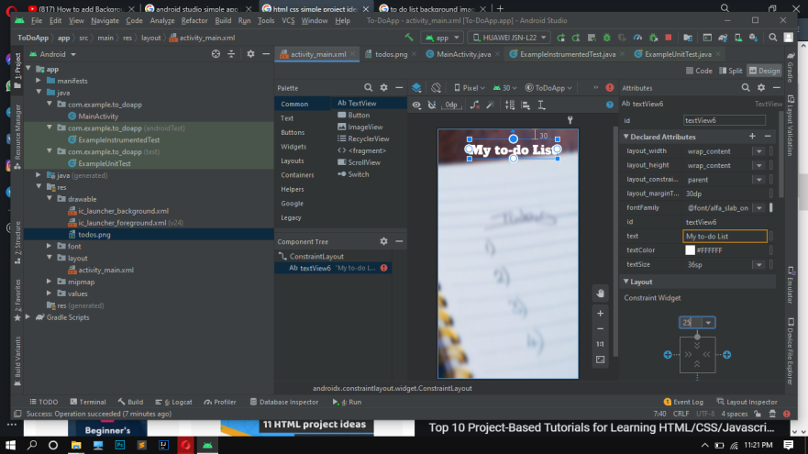

* **Add text field**
* **Apply constraints**
* **Change name and add hint “ENTER TASK”**

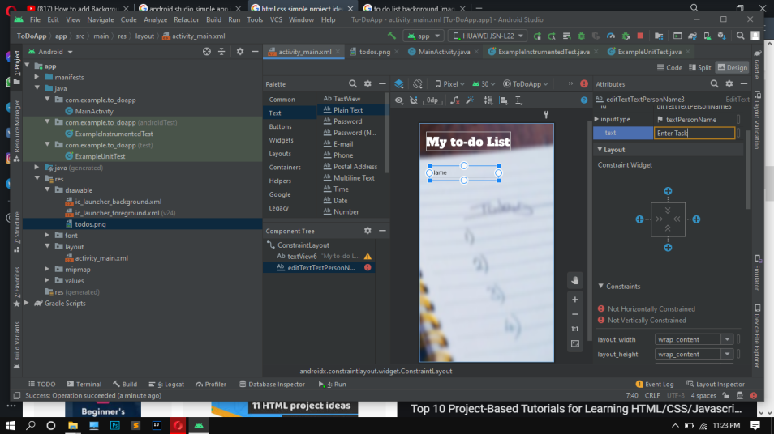

* **Drag and drop button**
* **Apply Vertical and Horizontal Constraints**
* **Change button text to “ADD”**

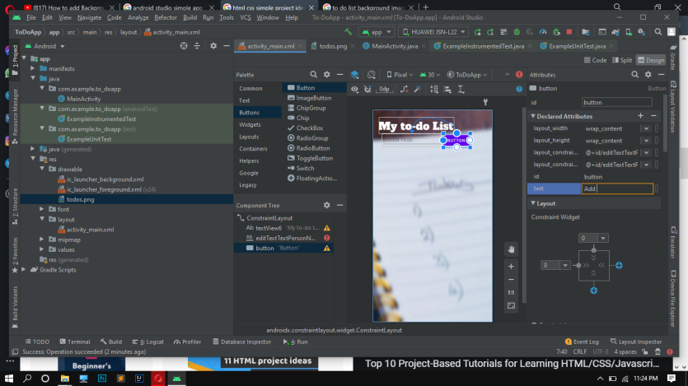

* **Drag and Drop textView**
* **Apply text formatting and padding etc.**
* **Apply their vertical and horizontal constraints**

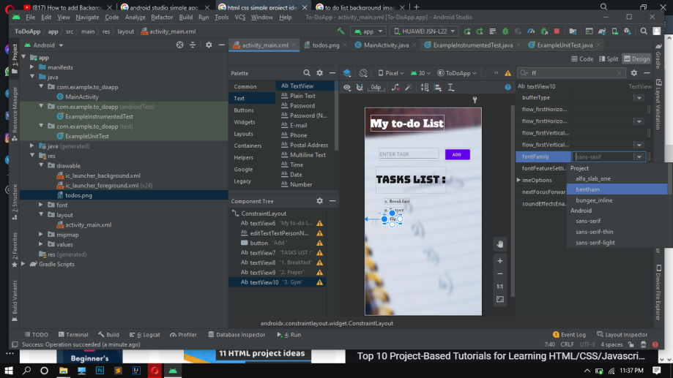

* **Drag and Drop buttons**
* **Apply Constraints**

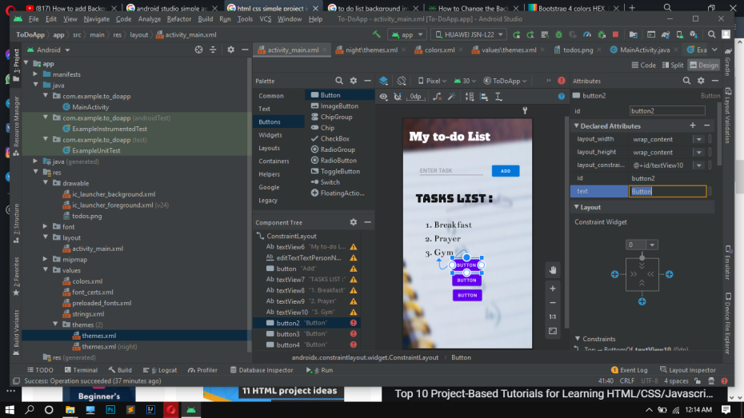

* **Change button texts**

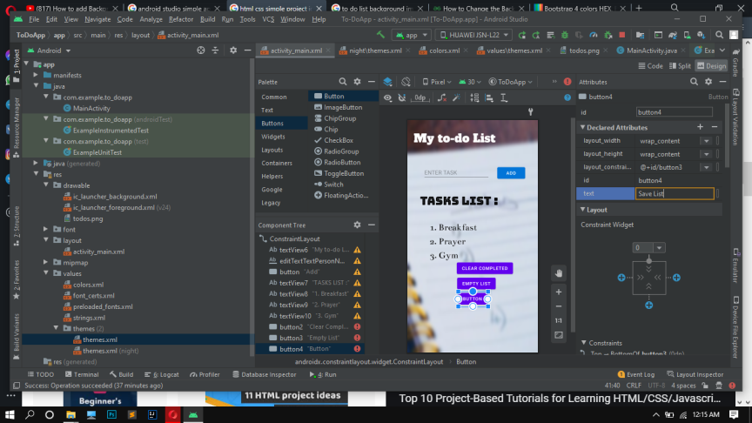

* **Change button colors from code section**
* **Align them center horizontally**

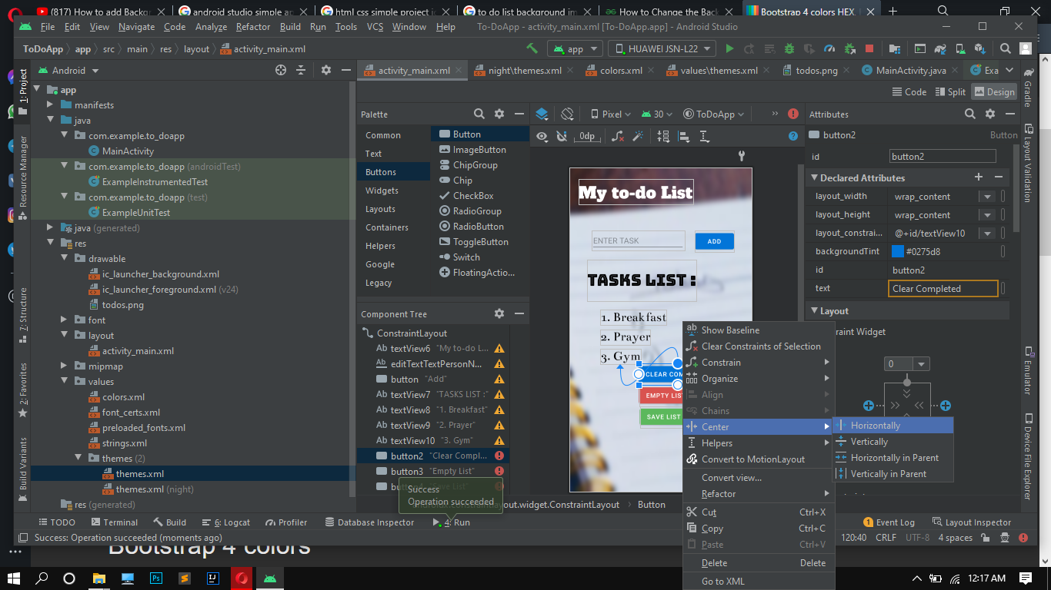

* **App final form running on device**
* **Action bar removed from themes**

